**TLS PKI**

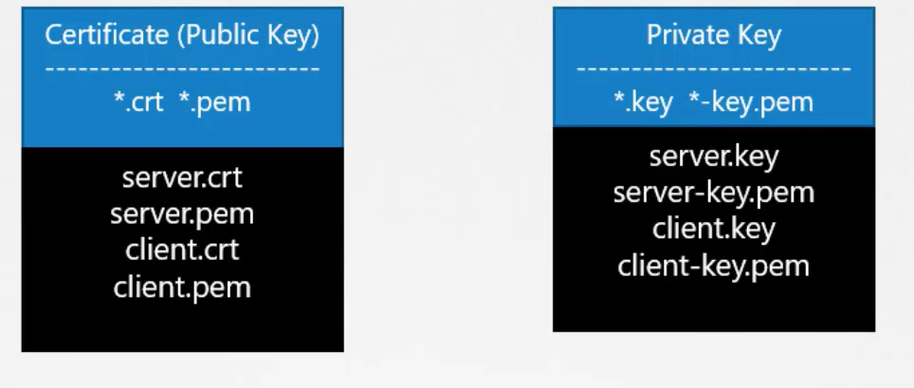

### One way SSL

SYMMETRIC ENCRYPTION

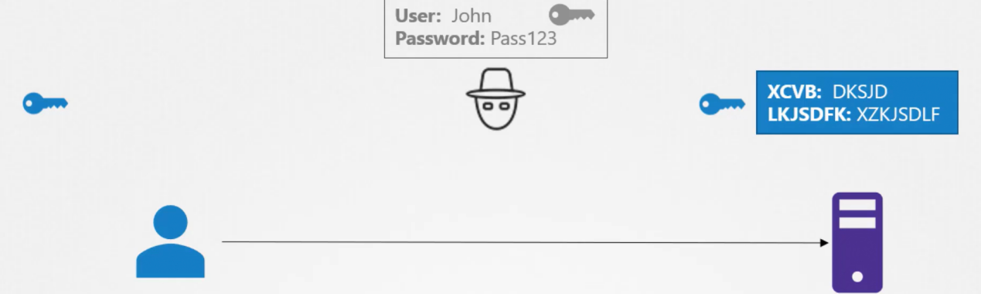

ASYMMETRIC ENCRYPTION

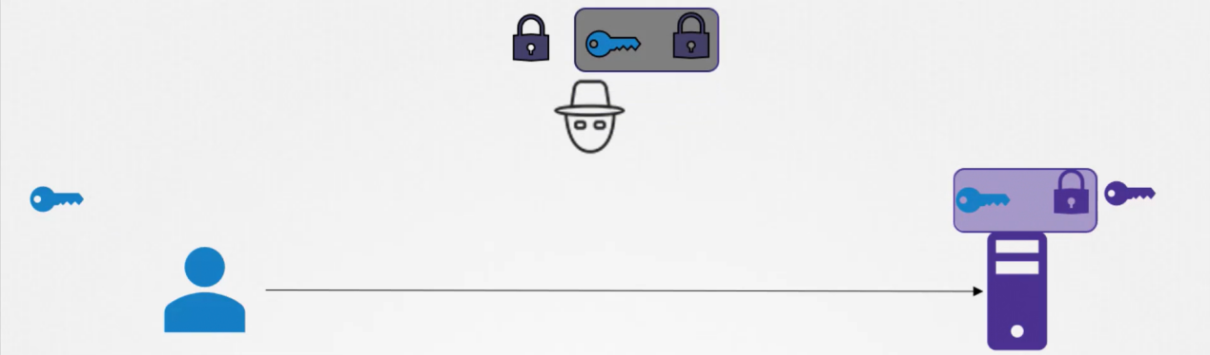

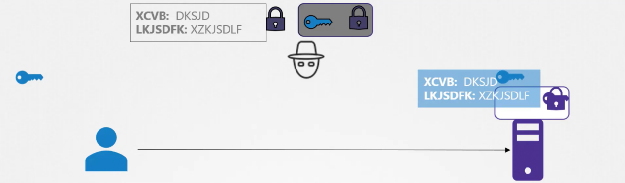

Certificate:

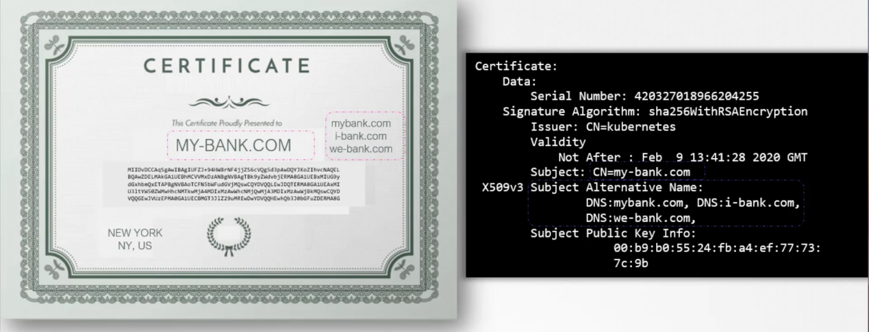

CA:

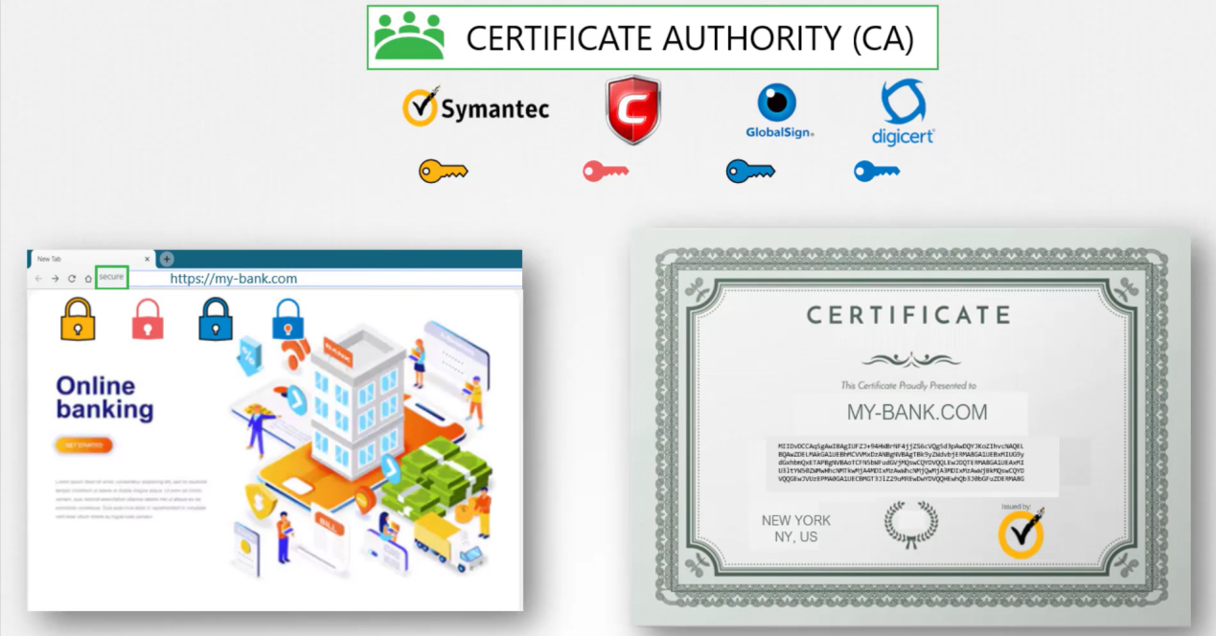

Mutual SSL(mTLS)

